Advanced Small Modular Reactors article

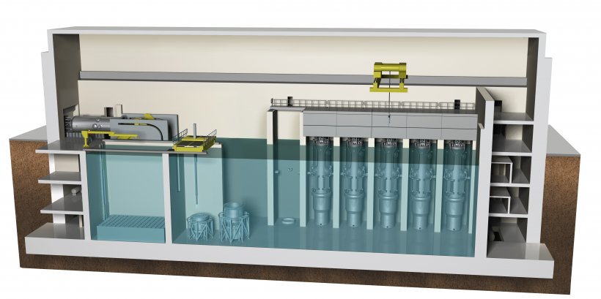

**Advanced Small Modular Reactors (SMRs)** are a key part of the Department’s goal to develop safe, clean, and affordable nuclear power options. The advanced SMRs currently under development in the United States represent a variety of sizes, technology options, capabilities, and deployment scenarios. These advanced reactors, envisioned to vary in size from tens of megawatts up to hundreds of megawatts, can be used for power generation, process heat, desalination, or other industrial uses. SMR designs may employ light water as a coolant or other non-light water coolants such as a gas, liquid metal, or molten salt.

Advanced SMRs offer [many advantages](https://www.energy.gov/ne/benefits-small-modular-reactors-smrs), such as relatively small physical footprints, reduced capital investment, ability to be sited in locations not possible for larger nuclear plants, and provisions for incremental power additions. SMRs also offer distinct safeguards, security and nonproliferation advantages.

The Department has long recognized the transformational value that advanced SMRs can provide to the nation’s economic, energy security, and environmental outlook. Accordingly, the Department has provided substantial support to the development of light water-cooled SMRs, which are under licensing review by the Nuclear Regulatory Commission (NRC) and will likely be deployed in the late 2020s to early 2030s. The Department is also interested in the development of SMRs that use nontraditional coolants such as liquid metals, salts, and gases for the potential safety, operational, and economic benefits they offer.

Advanced SMR R&D Program

Building on the successes of the [SMR Licensing Technical Support (LTS)](https://www.energy.gov/ne/smr-licensing-technical-support-lts-program) program, the Advanced SMR R&D program was initiated in FY2019 and supports research, development, and deployment activities to accelerate the availability of U.S.-based SMR technologies into domestic and international markets. Significant technology development and licensing risks remain in bringing advanced SMR designs to market and government support is required to achieve domestic deployment of SMRs by the late 2020s or early 2030s.  Through this program, the Department has partnered with NuScale Power and Utah Associated Municipal Power Systems (UAMPS) to demonstrate a first-of-a-kind reactor technology at the Idaho National Laboratory this decade. Through these efforts, the Department will provide broad benefits to other domestic reactor developers by resolving many technical and licensing issues that are generic to SMR technologies, while promoting U.S. energy independence, energy dominance, and electricity grid resilience, and assuring that there is a future supply of clean, reliable baseload power.

U.S. Industry Opportunities for Advanced Nuclear Technology Development

The Department issued a multi-year cost-shared funding opportunity (*U.S. Industry Opportunities for Advanced Nuclear Technology Development*, DE-FOA-0001817) in 2018 to support innovative, domestic nuclear industry-driven concepts that have high potential to improve the overall economic outlook for nuclear power in the United States. This funding opportunity will enable the development of existing, new, and next-generation reactor designs, including SMR technologies.

The scope of the funding opportunity is very broad and solicits activities involved in finalizing the most mature SMR designs; developing manufacturing capabilities and techniques to improve cost and efficiency of nuclear builds; developing plant structures, systems, components, and control systems; addressing regulatory issues; and other technical needs identified by industry. The funding opportunity will provide awards sized and tailored to address a range of technical and regulatory issues impeding the progress of advanced reactor development. Read more on the [FOA here](https://www.id.energy.gov/NEWS/FOA/FOAOpportunities/FOA.htm). Also, see the [awards that have been selected to date](https://www.energy.gov/ne/initiatives/funding-opportunities/industry-foa-awardees).